- R is an open-source programming language mainly used for statistics, data analysis, and data visualization. It allows users to analyze massive datasets and create graphs through code. RStudio is the IDE used with R because it provides a more organized and beginner-friendly interface. It includes a script editor, console, plotting area, and workspace tools all in one application. RStudio even offers an environment workspace, where users can see values created through their code.
A major advantage of R is its ability to create graphs and charts visually by using code instead of heavily relying on GUI tools. This helps users to customize charts more easily. I created a scatter plot and a bar chart using basic R functions after researching R and RStudio.

- Compared to Excel (I have never worked with Tableau), R is much more code focused. Excel is very simple to use for smaller datasets and quick graphs. However, R provides more flexibility and automation when everything is written as reusable code. There is a slight disadvantage with R, as for a beginner to computer science as a whole, would have a harder time learning it and becoming a “master” at R. R offers advantages as well, being a better option for larger datasets, repeated analysis, and customized visualizations. Overall, this assignment helped introduce the basics of R and RStudio while showing how code-based graphics can be used to create professional visualizations. Though programs like Excel are easier to learn for beginners, I think R offers more control and long-term usefulness, especially for data analysis projects.
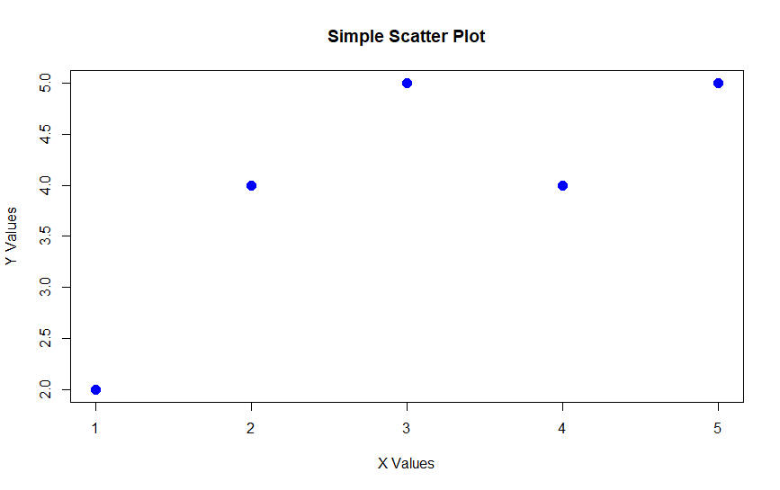
- This scatter plot was created with R code and shows simple x and y values.
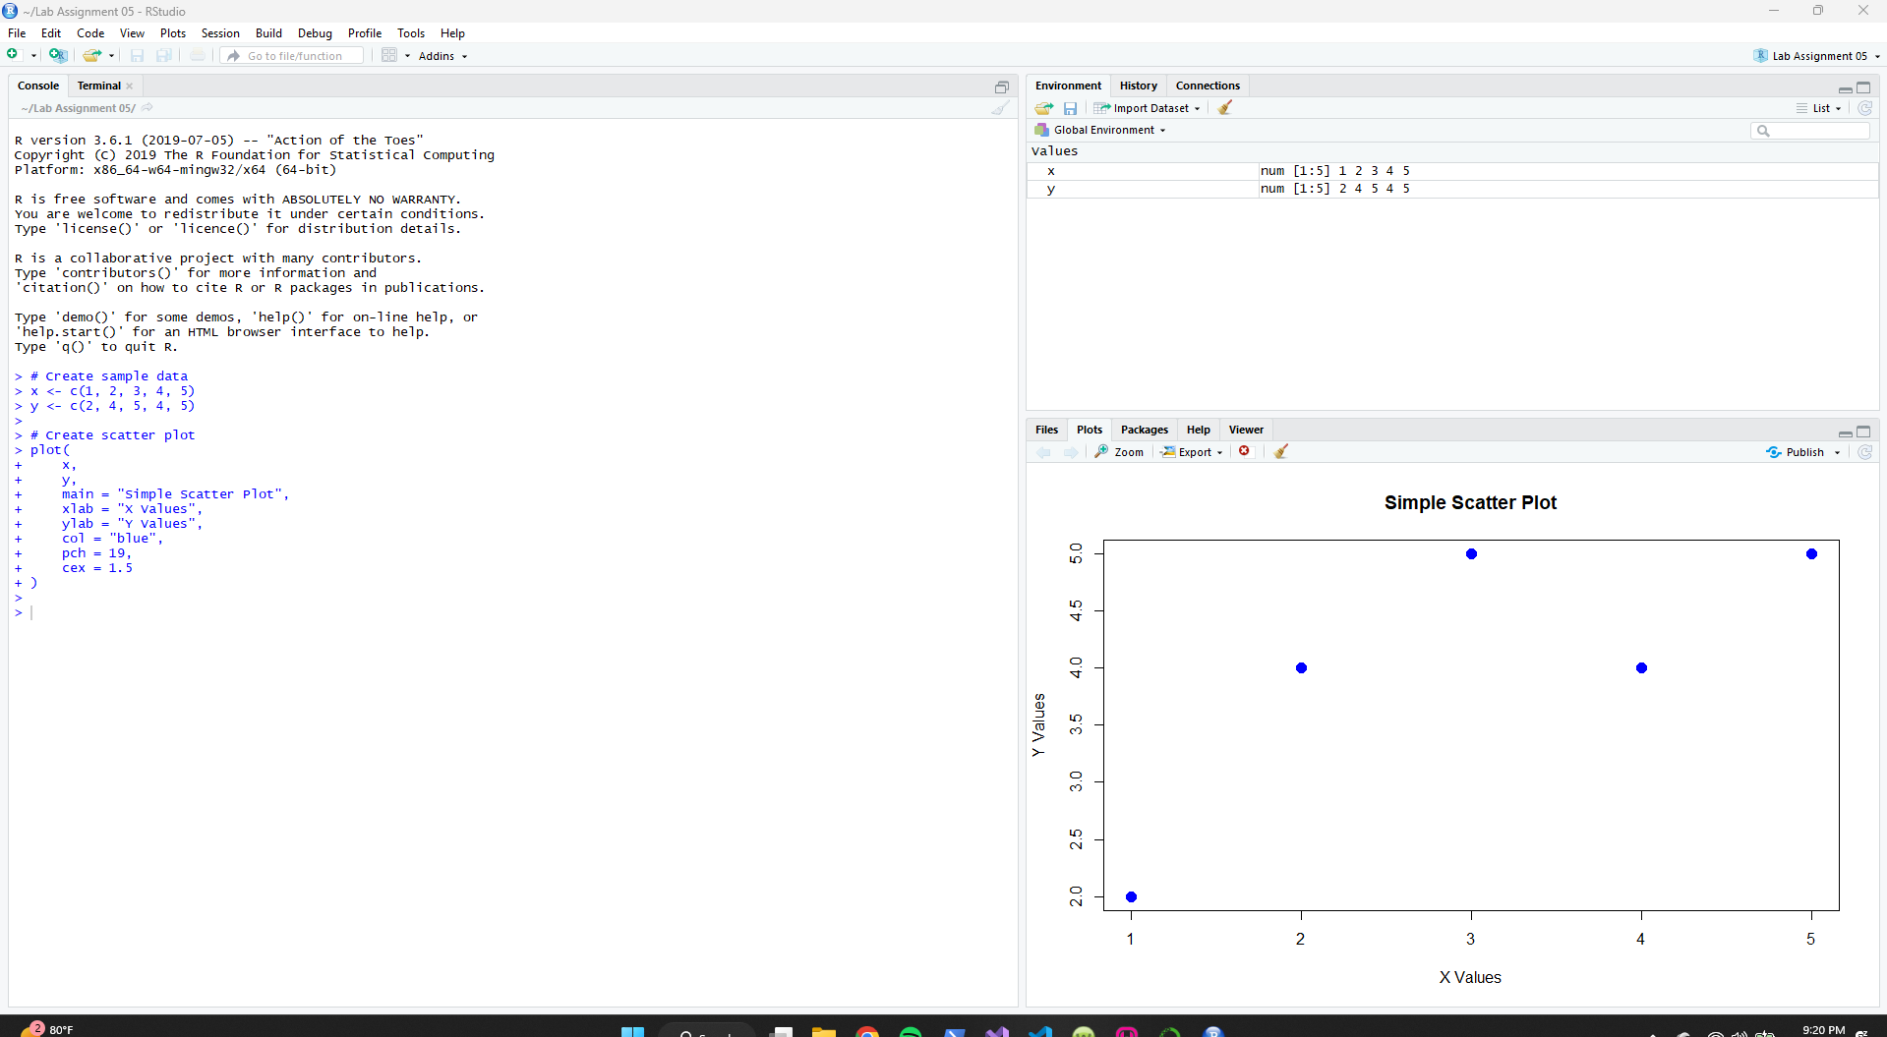

This bar chart was also created with R code. I followed your instructions in making sure I went as simple as possible with my code and visualizations.
